Wykład 2
Powiązania między klasami – projekt i implementacja
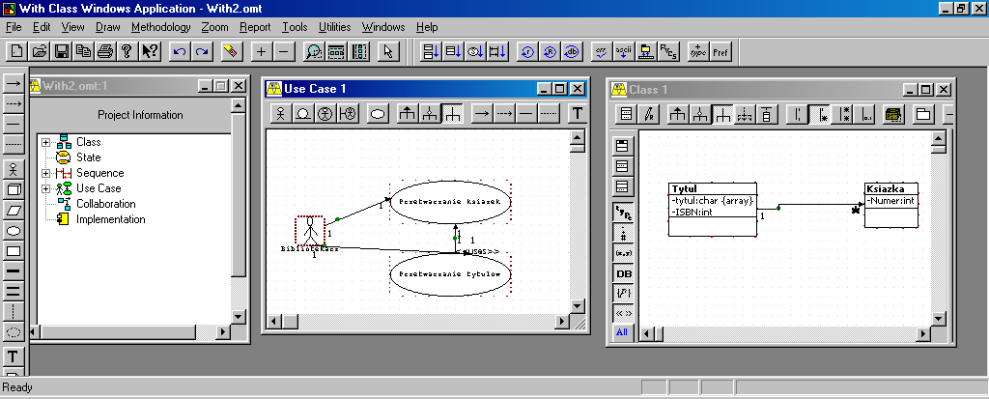
Rys.1 . Diagram przypadków użycia i diagram klas
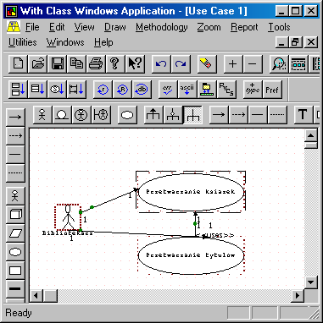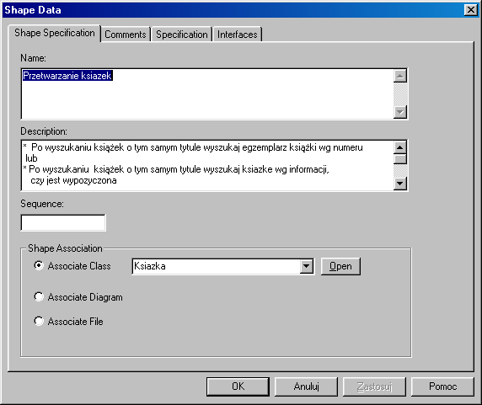
Rys.2. Przykład opisu przypadku użycia Przetwarzanie książek
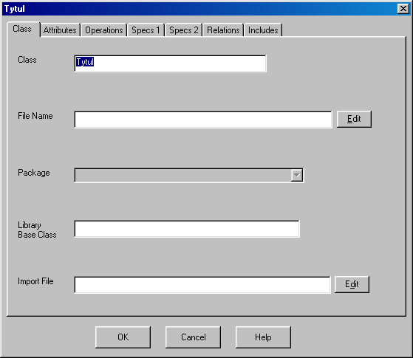
Rys.3. Przykład formularza do opisu klasy
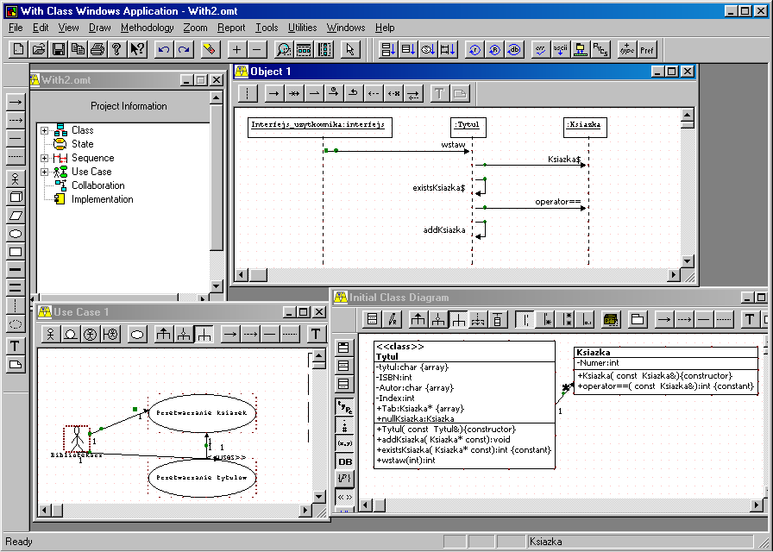Rys. 4. Kolejny etap rozwoju projektu
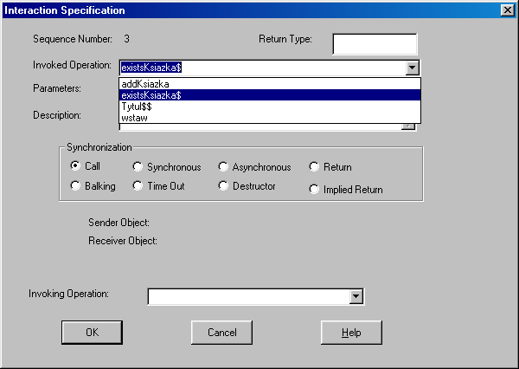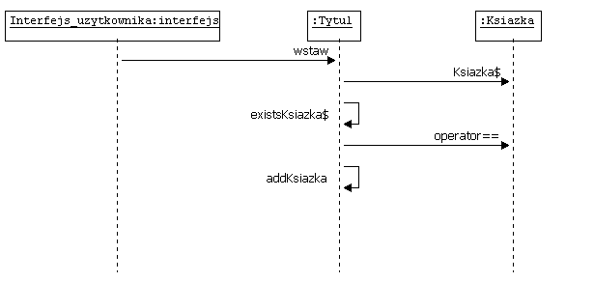

Rys.5. Formularz opisu diagramu sekwencji. Diagram sekwencji wyraża scenariusz przypadku użycia Przetwarzanie książek

Kod źródłowy
// Class: Tytul //ANSI C++
#ifndef __TYTUL_H //Required for Tytul class
#define __TYTUL_H
#ifndef __IOSTREAM_H //Required for cin and cout
#include <iostream.h>
#endif
#ifndef __CSTRING_H //Required for CString class
#include <String.h>
#endif //Required for 1:M association classes
#ifndef __KSIAZKA_H //Ksiazka
#include "Ksiazka.h"
#endif
const int DL = 20;
const int maxNumberOfKsiazkas = 100;
typedef char string [DL];

class Tytul
{
char tytul[DL]; //Attribute data member
int ISBN; //Attribute data member
char Autor [DL]; //Attribute data member
int Index; //Index for array of 1:M association objects
//1:M association object data member
//Change C array to C++ collection class with iterator
Ksiazka* Tab [maxNumberOfKsiazkas ];
// Null association object for initialization of association object data member
Ksiazka nullKsiazka;
protected:
public:
//Default constructor alternative to compiler provided default constructor
//Ensure correct initial values
//Initialization list has members in the order declared
//Association object data member pointers initialized to null association object
Tytul ();
//Constructor with arguments
//Update to argument list to initialize base class data members,
//e.g. (int aNumber) : BaseClass (aNumber)
Tytul ( char aTytul[], int aISBN, char aAutor[] ) ;
Tytul (const Tytul& aTytul ); //Copy Constructor
Tytul& operator= (const Tytul& aTytul); //Operator= Assignment Operator
int operator== (const Tytul& aTytul) const; //Operator== Equality Operator
friend ostream& operator<< (ostream& os, const Tytul& aTytul); //Operator<<for cout
friend istream& operator>> (istream& is, Tytul& aTytul); //Operator>> for cin
//Get accessor function for non-static attribute data member
const char* getTytul() const { return tytul; }
//Get accessor function for non-static attribute data member
int getISBN() const { return ISBN; }
//Get accessor function for non-static attribute data member
const char* getAutor() const { return Autor;}
//Set accessor function for non-static attribute data member
void setTytul (const char aTytul[]){ strcpy(tytul, aTytul); }
//Set accessor function for non-static attribute data member
void setISBN (const int aISBN) { ISBN = aISBN; }
//Set accessor function for non-static attribute data member
void setAutor (const char aAutor[]) { strcpy(Autor,aAutor); }
//Get accessor function for 1:M association collection
Ksiazka* const* getKsiazkaCollection() const ;
//Set accessor function for 1:M association collection
void setKsiazkaCollection (Ksiazka* const * aKsiazkaCollection);
//Add function for 1:M association object data member
void addKsiazka (Ksiazka* const aKsiazka); //throw (string)
//Remove function for 1:M association object data member
//Warning delete -- object if dynamic object
void removeLastKsiazka ( ) ; //throw (string)
//Remove all function for 1:M association object data member
//Warning delete -- object if dynamic object
void removeAllKsiazkas ( ) ; //throw (string)
//Get accessor function for 1:M association object data member
const Ksiazka* getFirstKsiazka() const ; //throw (string)
//Exists function for 1:M association object data member
int existsKsiazka() const ;
//Exists function for 1:M association object data member
int existsKsiazka (Ksiazka* const aKsiazka) const ;
~ Tytul ( ) { } //Destructor - Delete any pointer data members that used new in constructors
//Destructor should be virtual if and only if class contains at least one virtual function
//Objects destroyed in the reverse order of the construction order
int Tytul::wstaw(int numer_); //funkcja programisty
};
#endif

// Class: Tytul
//////////////////////////.cpp file/////////////////////////////////////////////////////
#include "Tytul.h"
// Functions for class Tytul
//Default constructor alternative to compiler provided default constructor
//Association object data member pointers initialized to null association object
Tytul::Tytul (): ISBN(0)
{ strcpy(tytul,"");
strcpy(Autor,"");
Index = 0; //Index for array of 1:M association objects
//Initialization of array of 1:M association objects to null association objects
for ( int i = 0; i < maxNumberOfKsiazkas; i++) Tab [i ] = &nullKsiazka;
}
//Constructor with arguments
//Update to argument list to initialize base class data members and const data members
//e.g. (int aNumber) : BaseClass (aNumber) , constMinimumValue (aMinimumValue)
Tytul::Tytul ( char aTytul[], int aISBN, char aAutor[] )
{ strcpy(tytul,aTytul); //Initialization of attributes
ISBN = aISBN; //Initialization of attributes
strcpy(Autor, aAutor); //Initialization of attributes
Index = 0; //Index for array of 1:M association objects
//Initialization of array of 1:M association objects to null association objects
for ( int i = 0; i < maxNumberOfKsiazkas; i++) Tab [i ] = &nullKsiazka;
}
//Copy constructor alternative to compiler provided default copy constructor
Tytul::Tytul (const Tytul& aTytul )
{ int i = 0;
Index = aTytul.Index; //Index for array of 1:M association objects
strcpy(tytul,aTytul.tytul);
ISBN = aTytul.ISBN;
strcpy(Autor,aTytul.Autor);
//Initialization of pointers to null association object
//for ( i = 0; i < maxNumberOfKsiazkas; i++) Tab [i ] = &nullKsiazka;
//Commented out shallow copy
//for ( i = 0; i < maxNumberOfKsiazkas; i++) Tab [i ] = aTytul.Tab [i ] ;
for (i = 0; i < aTytul.Index; i++)
{ Tab[i]=new Ksiazka;
*Tab [i ] = *aTytul.Tab [i ] ;
}
for (i = aTytul.Index; i <maxNumberOfKsiazkas; i++)
{ Tab[i]= &nullKsiazka;
}
}
//Operator= Assignment Operator alternative to compiler provided operator=
Tytul& Tytul::operator= (const Tytul& aTytul)
{ if (this == &aTytul) return *this;
int i = 0;
strcpy(tytul,aTytul.tytul);
ISBN = aTytul.ISBN;
strcpy(Autor,aTytul.Autor);
for (;i<Index;i++) delete Tab[i];
//for (i = 0; i < maxNumberOfKsiazkas; i++) Tab [i ] = &nullKsiazka ;
//Initialization of pointers to null association object
Index=aTytul.Index;
for (i = 0; i < Index; i++)
{ Tab[i]=new Ksiazka;
*Tab [i ] = *aTytul.Tab [i ] ; }
for (i = Index; i <maxNumberOfKsiazkas; i++)
{ Tab[i]= &nullKsiazka; }
return *this;
}
//Operator== Equality Operator
int Tytul::operator== (const Tytul& aTytul) const
{ return (
//Equality check for 1:1 aggregation part data members
//Equality check for 1:M aggregation parts
//Update for the correct number of aggregation part objects
//Equality check for 1:M association objects for shallow compare
//Update for the correct number of associated objects
//( Tab [0 ] == aTytul.Tab [0 ])&&
//( Tab [1 ] == aTytul.Tab [1 ])&&
//( Tab [2 ] == aTytul.Tab [2 ])&&
//( Tab [3 ] == aTytul.Tab [3 ])&&
//Equality check for attribute data members
(!strcmp(tytul,aTytul.tytul)) &&
(ISBN == aTytul.ISBN) &&
(strcmp(Autor, aTytul.Autor))
);
}
//Operator<< extraction for cout
ostream& operator<< (ostream& os, const Tytul& aTytul)
{ int i = 0;
os << "Object Attribute Values - Class Tytul" << endl;
os << "Tytul: " << aTytul.tytul << endl;
os << "ISBN: " << aTytul.ISBN << endl;
os << "Autor: " << aTytul.Autor << endl;
for (i = 0; i < maxNumberOfKsiazkas; i++)
{ if ( aTytul.Tab [i ] != &aTytul.nullKsiazka)
os << " Tab: " << *aTytul.Tab [i ] << endl; }
return os;
}
//Operator>> insertion for cin
istream& operator>> (istream& is, Tytul& aTytul)
{ int i = 0;
cout << "\nEnter Object Attribute Values or 0 - Class Tytul";
cout << "\nEnter Tytul : " << endl;
is >> aTytul.tytul;
cout << "\nEnter ISBN : " << endl;
is >> aTytul.ISBN;
cout << "\nEnter Autor : " << endl;
is >> aTytul.Autor;
for (i = 0; i < maxNumberOfKsiazkas; i++)
{ if ( aTytul.Tab [i ]!= &aTytul.nullKsiazka)
is >> *aTytul.Tab [i ] ; }
return is;
}

//Get accessor function for 1:M association object data member
const Ksiazka* Tytul::getFirstKsiazka() const //throw (string)
{ string KsiazkaCollectionEmpty;
if ( Index == 0 ) throw KsiazkaCollectionEmpty;
else return Tab [Index-1 ];
}
//Get accessor function for 1:M association collection
Ksiazka* const* Tytul::getKsiazkaCollection() const
{ return Tab;
}
//Set accessor function for 1:M association collection
void Tytul::setKsiazkaCollection (Ksiazka* const * aKsiazkaCollection)
{ int i = 0;
// for ( i = 0; i < maxNumberOfKsiazkas; i++) Tab [ i ] = &nullKsiazka ;
for ( int i = 0; i < maxNumberOfKsiazkas; i++) Tab [ i ] = aKsiazkaCollection [ i ];
}
//Add function for 1:M association object data member
void Tytul::addKsiazka (Ksiazka* const aKsiazka) //throw (string)
{ string KsiazkaCollectionFull;
if ( Index == maxNumberOfKsiazkas) throw KsiazkaCollectionFull;
else
{ Tab [ Index ] = aKsiazka ;
Index++;
}
}
//Remove function for 1:M association object data member
//Warning delete -- object if dynamic object
void Tytul::removeLastKsiazka ( ) //throw (string)
{ string KsiazkaCollectionEmpty;
if ( Index == 0 ) throw KsiazkaCollectionEmpty;
else
{ Index--;
delete Tab [Index];
Tab [Index ] = &nullKsiazka ;
}
}
//Remove all function for 1:M association object data member
//Warning delete -- object if dynamic object
void Tytul::removeAllKsiazkas ( ) //throw (string)
{ string KsiazkaCollectionEmpty;
if ( Index == 0 ) throw KsiazkaCollectionEmpty;
for (int i = 0; i < Index; i++) delete Tab [i ];
for ( i = 0; i < maxNumberOfKsiazkas; i++)
Tab [i ] = &nullKsiazka;
Index=0;}
//Exists function for 1:M association object data member
int Tytul::existsKsiazka() const
{ if ( Tab [0 ] == &nullKsiazka ) return 0; else return 1; }

//Exists function for 1:M association object data member
int Tytul::existsKsiazka (Ksiazka* const aKsiazka) const
{ if ( Tab [ 0 ] == &nullKsiazka ) return 0;
for (int i = 0; i < Index; i++)
{ if ( *Tab [i ] == *aKsiazka ) return 1;
}
return 0;}

To jest kod wstawiony przez programistę
int Tytul::wstaw(int numer_)
{Ksiazka* k1=new Ksiazka(numer_);
int a;
if (k1==NULL) a=0;
else
if (existsKsiazka(k1)==1)
{delete k1;
a=0;}
else
{addKsiazka(k1);
a=1; }
return a;}

// Class: Ksiazka //ANSI C++
#ifndef __KSIAZKA_H /Required for Ksiazka class
#define __KSIAZKA_H
#ifndef __IOSTREAM_H /Required for cin and cout
#include <iostream.h>
#endif
#ifndef __CSTRING_H //Required for CString class
#include <String.h>
#endif

class Ksiazka
{
int Numer; //Attribute data member
protected:
public:
//Default constructor alternative to compiler provided default constructor
//Ensure correct initial values
//Initialization list has members in the order declared
//Association object data member pointers initialized to null association object
Ksiazka ();
//Constructor with arguments
//Update to argument list to initialize base class data members,
//e.g. (int aNumber) : BaseClass (aNumber)
Ksiazka ( int aNumer ) ;
//Copy Constructor
Ksiazka (const Ksiazka& aKsiazka );
//Operator= Assignment Operator
Ksiazka& operator= (const Ksiazka& aKsiazka);
//Operator== Equality Operator
int operator== (const Ksiazka& aKsiazka) const;
//Operator<< for cout
friend ostream& operator<< (ostream& os, const Ksiazka& aKsiazka);
//Operator>> for cin
friend istream& operator>> (istream& is, Ksiazka& aKsiazka);
//Get accessor function for non-static attribute data member
int getNumer() const
{ return Numer;}
//Set accessor function for non-static attribute data member
void setNumer (const int aNumer)
{ Numer = aNumer;
}
~ Ksiazka ( ) { } //Destructor - Delete any pointer data members that used new in constructors
//Destructor should be virtual if and only if class contains at least one virtual function
//Objects destroyed in the reverse order of the construction order
};
#endif
// Class: Ksiazka
//////////////////////////.cpp file/////////////////////////////////////////////////////
#include "Ksiazka.h"
// Functions for class Ksiazka
//Default constructor alternative to compiler provided default constructor
//Association object data member pointers initialized to null association object
Ksiazka::Ksiazka () : Numer(0)
{ //Initialization of array of 1:M association objects to null association objects
}
//Constructor with arguments
//Update to argument list to initialize base class data members and const data members
//e.g. (int aNumber) : BaseClass (aNumber) , constMinimumValue (aMinimumValue)
Ksiazka::Ksiazka ( int aNumer )
{ Numer = aNumer; //Initialization of attributes
//Initialization of array of 1:M association objects to null association objects
}
//Copy constructor alternative to compiler provided default copy constructor
Ksiazka::Ksiazka (const Ksiazka& aKsiazka )
{int i = 0;
Numer = aKsiazka.Numer;
}
//Operator= Assignment Operator alternative to compiler provided operator=
Ksiazka& Ksiazka::operator= (const Ksiazka& aKsiazka)
{ if (this == &aKsiazka) return *this;
int i = 0;
Numer = aKsiazka.Numer;
return *this;}
//Operator== Equality Operator
int Ksiazka::operator== (const Ksiazka& aKsiazka) const
{ return (
//Equality check for 1:1 aggregation part data members
//Equality check for 1:M aggregation parts
//Update for the correct number of aggregation part objects
//Equality check for 1:M association objects for shallow compare
//Update for the correct number of associated objects
//Equality check for attribute data members
(Numer == aKsiazka.Numer) );
}
//Operator<< extraction for cout
ostream& operator<< (ostream& os, const Ksiazka& aKsiazka)
{ int i = 0;
os << "Object Attribute Values - Class Ksiazka" << endl;
os << "Numer: " << aKsiazka.Numer << endl;
return os;
}
//Operator>> insertion for cin
istream& operator>> (istream& is, Ksiazka& aKsiazka)
{ int i = 0;
cout << "\nEnter Object Attribute Values or 0 - Class Ksiazka";
cout << "\nEnter Numer : " << endl;
is >> aKsiazka.Numer;
return is;}
To jest kod wstawiony przez programistę

#include "Ksiazka.h"
#include "Tytul.h"
#include <iostream.h>
void main()
{ Tytul t1;
cin>>t1;
if (t1.wstaw(1)==1) cout<<t1;
else cout<<"Nie wstawiono ksiazki"<<endl;
if (t1.wstaw(1)==1) cout<<t1;
else cout<<"Nie wstawiono ksiazki"<<endl;
if (t1.wstaw(2)==1) cout<<t1;
else cout<<"Nie wstawiono ksiazki"<<endl;
t1.removeAllKsiazkas ( );
cout<<t1;}

